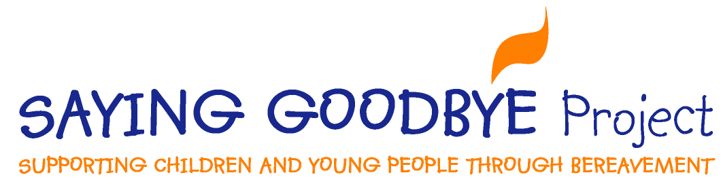
Bereavement and other support organisations for contacting whilst the Saying Goodbye Project is currently closed to referrals.
Child Bereavement UK | https://www.childbereavementuk.org/  0800 02 888 40 (Helpline weekdays 9am – 5pm) | For parents, carers, professionals and young people.  CBUK work in collaboration with the London Grid for Learning and provide free resources and training for school staff  https://www.childbereavementuk.org/online-learning-for-schools
Space2grieve | https://space2grieve.org.uk/  0751 937 6363  support@space2grieve.org.uk | Charity providing bereavement support for children, young people and adults living in Richmond. There is no charge for this service.
Kooth | https://www.kooth.com/ | On line mental health and well being support for young people  Includes links to crisis services
Anna Freud (national centre for children and families) | https://www.annafreud.org/  (0)20 7794 2313  info@annafreud.org | Useful information for parents and carers  Information and short training videos about traumatic bereavement specifically for schools and professionals
Rip Rap | http://www.riprap.org.uk/ | Support for young people when a parent has cancer
Cruse Bereavement Support | https://www.cruse.org.uk/  0808 808 1677 (Helpline 7 days a week, times vary) | National bereavement organisation, offering support via email and chat and online for adults and children and young people.  Lots of useful information on the website about bereavement
Hope Again | https://www.hopeagain.org.uk/ | The youth website of Cruse Bereavement Support

