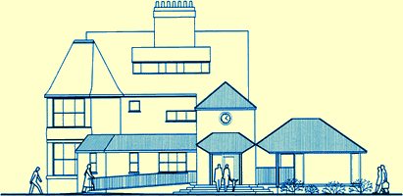

PATIENT PARTICIPATION GROUP
St Albans Surgery

Notes of the Meeting: Wednesday 19 February 2014

Present:
Denis Norton (DN) Chair, Chris Cookson(CC), Connie Page (CP), Tony Page(TP),
Judith Poulton (JP), Marian Robertson(MR)

Apologies:
Janet Balcomb(JB), Elaine Parrish, Mary Russell

1 New PPG member
DN reported that Mary Russell looked forward to joining future meetings of the PPG.

2 DES Contract
DN confirmed that there was nothing to report on three issues arising from the contract- implications for Practice and PPG
- draft 2014 Action Plan
- Funding for PPG activities

3 Patient Questionnaire
DN reported that he had been in correspondence with MR over the draft preparation of the questionnaire. MR agreed that given the tight timetable to manage the questionnaire and gather together all the data, it was necessary to finalise the draft and prepare copies for distribution the week beginning 24 February. MR readily accepted the offer of assistance from members of the PPG. MR would liaise with DN.

4 Better Care Fund Focus Group – February
TP had responded to KCCG but to date he had not received an answer.

5 PPG Network Meeting – Monday 10 March 2014
Notice had been given of the next meeting – JP was not able to attend; TP indicated his willingness to attend.

The date for the January CCG Forum had not been publicised and therefore
St Albans PPG had not attended. The next Forum was booked for 29 April in the Mayo Hall from 7pm – 9pm.

6 Tiffin Girls School project leaflet
PPG members discussed the success of the presentation and the intention to draft a leaflet for young people. TP had put some ideas together and presented the idea of the leaflet and its purpose to neighbours and friends. The reactions had been interesting and useful. Questions still needed to be answered as to who leaflet should be aimed and how should such a leaflet be distributed; what about the boys’ school? TP would follow through the ideas and talk to professionals eg school nurses to gauge their reaction.

7 Dr Chapman
MR advised the PPG that Dr Chapman had left the practice in February and the interviewing process was underway to make another appointment.

MR would consider proposing another member of staff to join the PPG meetings.

8 Date of next meeting: To be agreed

