How to get to the COVID CLINIC
You have been invited by your GP Practice to come and have your COVID 19 vaccination. This will involve two separate vaccinations a minimum of 21 days apart.
Make sure you have got your 2 appointments booked.
The vaccination programme is being delivered jointly with a number of other GP Practices across Kingston from a single designated site. This site is the University Health Centre at Kingston University, Penrhyn Road campus. The entrance to the Health Centre is on Grove Crescent – for SatNav or Google maps please use postcode KT1 2DD
IMPORTANT: Please note you will not be able to drive straightaway post vaccination and we may ask you to stay for up to 15 min for observation.
There is a small car park available for patients attending the clinic. The entrance to the car park is on Fassett Road and it will be clearly signposted. There are a number of designated disabled bays on the left hand side of the car park – these are reserved for patients requiring wheelchair assistance to get from their car to the Health Centre entrance. If needed please request assistance from one of the Marshalls on site. The car park is a short walk from the Health Centre entrance and our teams will be on site to guide you and offer assistance.
The local council have suspended the residential parking bays on Fassett Road and Grove Crescent (between the two green stars on the image below) for the duration of the clinics in order to facilitate the timely drop off and collection of patients.
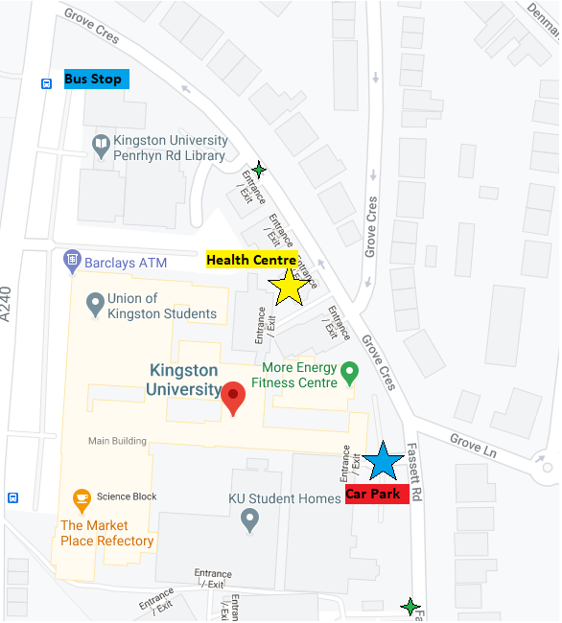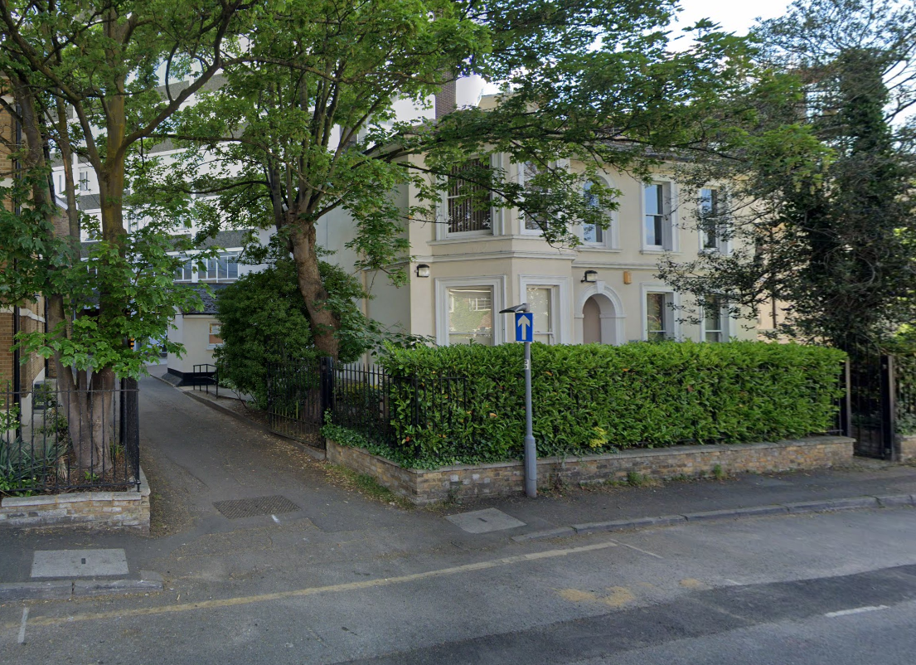
Due to the volume of vaccines that need to be delivered in a short timescale it is important that you attend your appointment on time. Similarly owing to limited parking spaces please do not arrive too early. Upon arrival, we would ask that any relatives/friends who have brought you to your appointment remain in the car as we need to maintain social distancing within the Health Centre setting.
If you are coming by Bus, the Kingston University/County Hall bus stop on Penrhyn Road is a short walk up Grove Crescent to the Health Centre entrance – shown above. The following buses stop here; K2, K3, 71, 281, 406 & 418
Upon arrival you should follow directions given by the marshals, requesting assistance where necessary, and make your way to the Health Centre entrance where you will be greeted by one of our Team.
Contact details for the duration of COVID clinics for patients who are already booked:
07498 654 003
Follow our website for more updates https://stalbansmedicalcentre.co.uk

