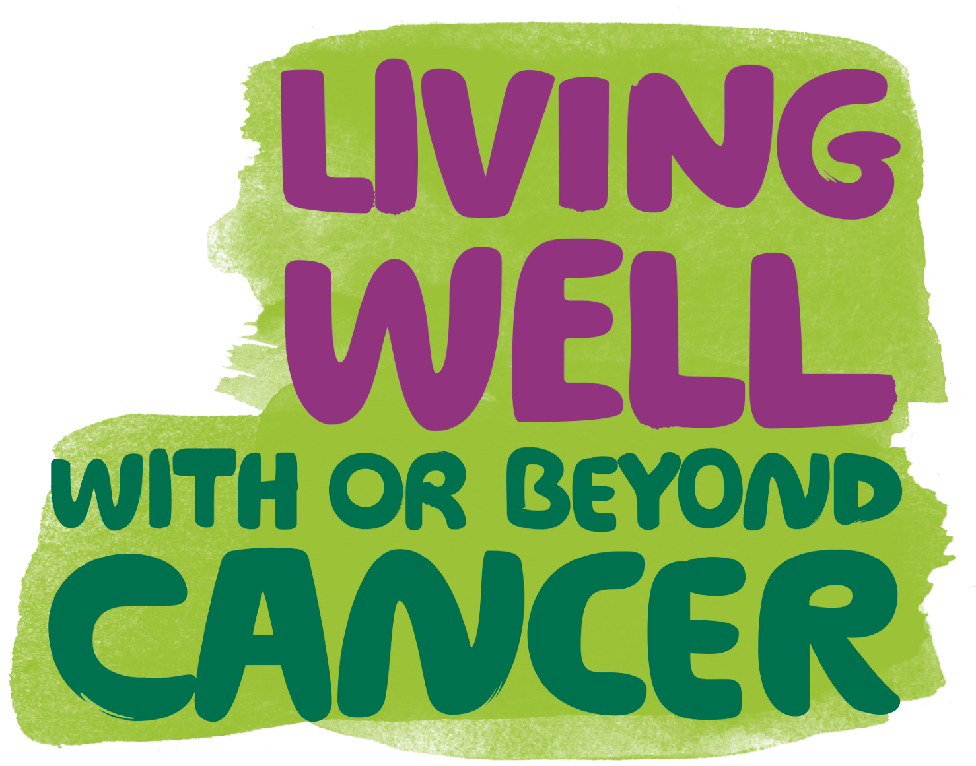
Macmillan Social Prescribing Helping you to improve your wellbeing and access services and activities in your local area.
The Macmillan Social Prescribing Service is available to cancer patients or family members/carers of someone with cancer or at heightened risk of developing cancer (aged 18+ years) and living in Kingston upon Thames
It supports you to:
- explore and define what is important for your wellbeing • identify and access the local activities and resources you need
Local activities include:
- health and wellbeing programmes
(e.g. walking groups, meditation groups)
- work and volunteering advice
(e.g. local employment support projects)
- learning and social opportunities
(e.g. art classes and gardening groups)
- practical support
(e.g. debt, benefits and money management advice)
- support groups
(e.g. parent, carer and patient support groups)
What support is provided?
We can support you over the phone or with a series of face-to-face sessions to explore your needs and help you to move forward.
You can ask to be referred by your GP, health professional, community service or you can call and arrange your first appointment.
The Macmillan Social Prescribing
07795 334 941
kingston.socialprescribing@nhs.net
Service is provided by Macmillan
Cancer Support, Kingston CCG, Kingston Public Health, and Kingston Council.
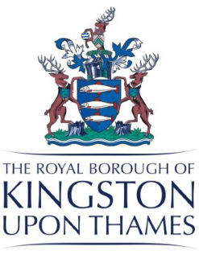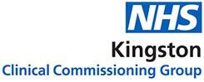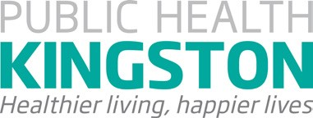
© Macmillan Cancer
Support, September 2017,
MACLASER 347. Registered
charity in England and Wales
(261017)
, Scotland (SC039907)
and Isle of Man (604).

Together with

