GP NATIONAL SURVEY 2025 - ANALYSIS

Vs national/regional
Across all the questions in the survey, except for two, our Practice rating was better the national/regional average.
The two exceptions were:
"% of pts who say that during their last general practice appt the healthcare professional was good at considering their mental health" (slightly lower) and
"% of pts who were offered a choice of location for their general practice appt" .
Vs our neighbours
Better news still, is the fact that our Practice scored higher than our neighbours at "% of patients who found it easy to get through to our GP practice by phone" or even through the NHS App. However, we scored less than our neighbours at " contacting the Practice via the Practice website."
It is also satisfying to know that our Practice scored much higher (circa by 20%) than our neighbours at patient able to speak/see their preferred choice of a healthcare professional.
Offering pts the choice of time/day, when they last tried to book a general practice appt is another indicator we could improve, as slightly less than one of the neighbours. It is worth checking how we scored last year.
Lastly, the overall experience of this GP practice reached 90% of pt satisfaction, higher than national/regional average and than our neighbours.

St Albans Patient Survey and Analysis - 2025

Q + A | Analysis | Action | Action competed
 | 56 patients answered:
If you use our website (https://www.stalbansmedicalcentre.co.uk), what would you change on it? |  | We try to keep a balance between appts bookable via app/different methods. Often speaking to patients help us to signpost to the best clinician.
Are you aware you can send a message (“Send us a message”) through our website to request a prescription, ask for results, ask for an appointment or anything else? | 37% | Maintain, keep promoting, offer on the phone and already on answering machine. | ongoing
Do you use NHS App for booking appointments, requesting prescriptions, accessing your online records? | 46% | Keep promoting for requesting scripts, accessing records. Option for scripts already on tel message. | ongoing
What is your preferred method of booking an appointment and why? | 18% NHS app / 70% by phone
If you have booked a GP appointment over the last 3 months, were you happy to give a reason for booking it and be signposted to an appropriate clinician? |  | Training receptionists on urgent calls. | ongoing
Are you aware of Pharmacy 1st initiative (whereby you can be seen quicker by your local pharmacist for certain conditions)? | 53% | Keep signposting where possible. | ongoing
Are you satisfied with our new telephone system, whereby you can request a call back? | 95% | The system always try to call patient back (if the option chosen by patient). However, it has got limited number of attempts and fails when patients do not answer it.
When you last booked an appointment on the phone, were you offered the option to choose face-to-face or telephone? | 57% | Always train reception to offer the choice. | ongoing
Are you happy with our “early commuters” (before 8am) GP/nurse appointments? | 30%
Did you know you can prebook a GP/nurse appointment up to 3 months in advance? | 30%
Any further comments to improve our services? |  | Re answering machine service: this has been changed/updated already. | yes
 | 68 patients answered:
Would you prefer to see your GP outside the core hours Monday to Friday early in the morning (from 7:30am) or in the evening (after 6:30pm)? | 42% AM / 22% Evening | (keep AM out of hours slots as they are?)

GP NATIONAL SURVEY 2024

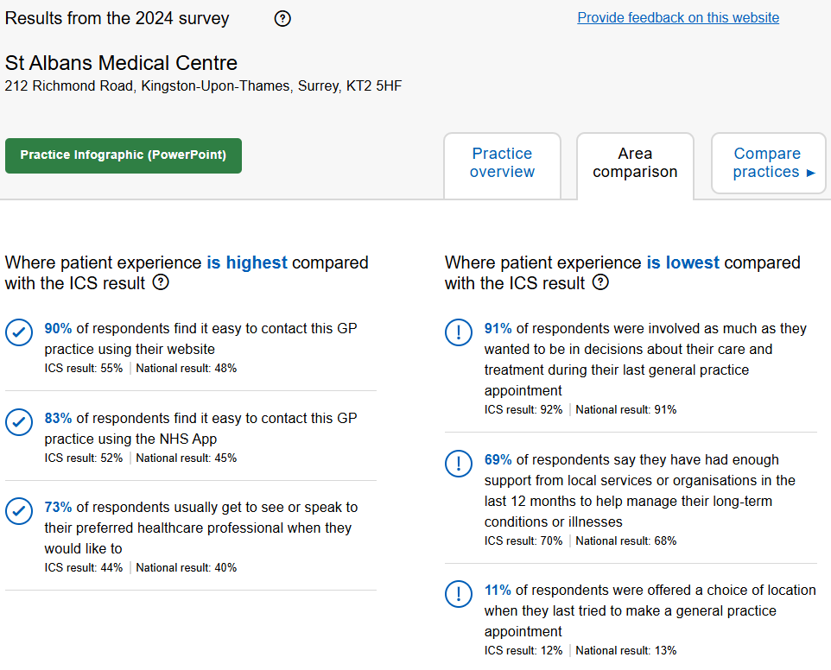

Practices Comparison

We have compared this survey with KHC and Canbury Medical Centre. The National results for each individual practice on same questions are pretty much the same, however, the breakdown can show the differences and how ahead or below we are on some topics such as:

- Access to website: we have great results with patient accessing our website if compared to the other two practices where we are 10% higher than KHC for instance when questioned how easy was to access it.
- NHS app: again, our patients are finding it very easy to contact us via the NHS app, where we are ahead in nearly 40% against Canbury Medical Centre.
- To speak or see a clinician at the time they wanted: here we are well ahead with 73% overall compared with KHC 33% only. We do have a very good system where patients are always given an option of appointment as well as the chance to choose and book it online.
- One of our lowest scores 69% on the question if patients have had any external support (local services or organisations) to help with the management of health conditions. This question is difficult to analyse as it depends a lot on what condition is being treated.
- The other area we scored low locally and in comparison with the other two local practices is whether patients were involved enough in making decisions about their care and treatment.
- Our lowest score is when offering a choice of location (to see a healthcare professional in person) where we reached 11% only compared to KHC for instance reaching their lowest on this topic at 14%.
- Other questions in the survey overall have very similar results.

